
do a deep research on claude haiku 4.5 latency on image recognition, what are the industry benchmark on image recognition by using GenAI
Now I have comprehensive research to provide a detailed analysis. Let me compile the final answer.
Deep Research: Claude Haiku 4.5 Image Recognition Latency and GenAI Image Recognition Industry Benchmarks
Claude Haiku 4.5 Visual Recognition Performance
Visual Reasoning Accuracy on MMMU Benchmark
Claude Haiku 4.5 demonstrates impressive visual reasoning capabilities with a 73.2% accuracy score on the MMMU (Massive Multi-discipline Multimodal Understanding) benchmark, achieved with a 128,000-token thinking budget. This performance places it in close proximity to Claude Sonnet 4, which achieved 74.4% on the same benchmark, and well above many open-source alternatives. For context, GPT-5 leads the benchmark at 84.2% accuracy, while Claude Opus 4.5 (Thinking) reaches 83.4%.^{[1][2][3]}
The MMMU benchmark is particularly valuable because it tests multimodal models' ability to process and reason about graduate-level questions across multiple disciplines where visual information is critical to finding correct answers. Unlike basic visual perception tasks, MMMU requires sophisticated integration of advanced multimodal analysis with domain-specific knowledge, making Haiku 4.5's 73.2% score a meaningful achievement for a compact, cost-efficient model.^{[4][5]}
Response Latency Characteristics
While specific latency measurements for Claude Haiku 4.5 image recognition are not extensively published in current benchmarks, the model operates within the broader pattern of Anthropic's multimodal LLMs. The model achieves 100-200+ tokens per second throughput once inference begins, and is reported to run 4-5 times faster than Claude Sonnet 4.5 in general operations. For latency-sensitive image recognition applications, Claude Haiku 4.5 delivers significantly faster response times compared to larger reasoning models, though exact millisecond-level measurements for image processing specifically remain proprietary to Anthropic.^{[6][7]}
The time to first token (TTFT) for Claude Sonnet 4.5 averages 1.80 seconds end-to-end, and Haiku 4.5 should deliver substantially faster performance given its optimization for speed. This is considerably slower than specialized fast models like GPT-4o (0.32 seconds) or Gemini 2.5 Flash (0.40 seconds), but the quality-speed tradeoff differs across use cases.^{[8]}
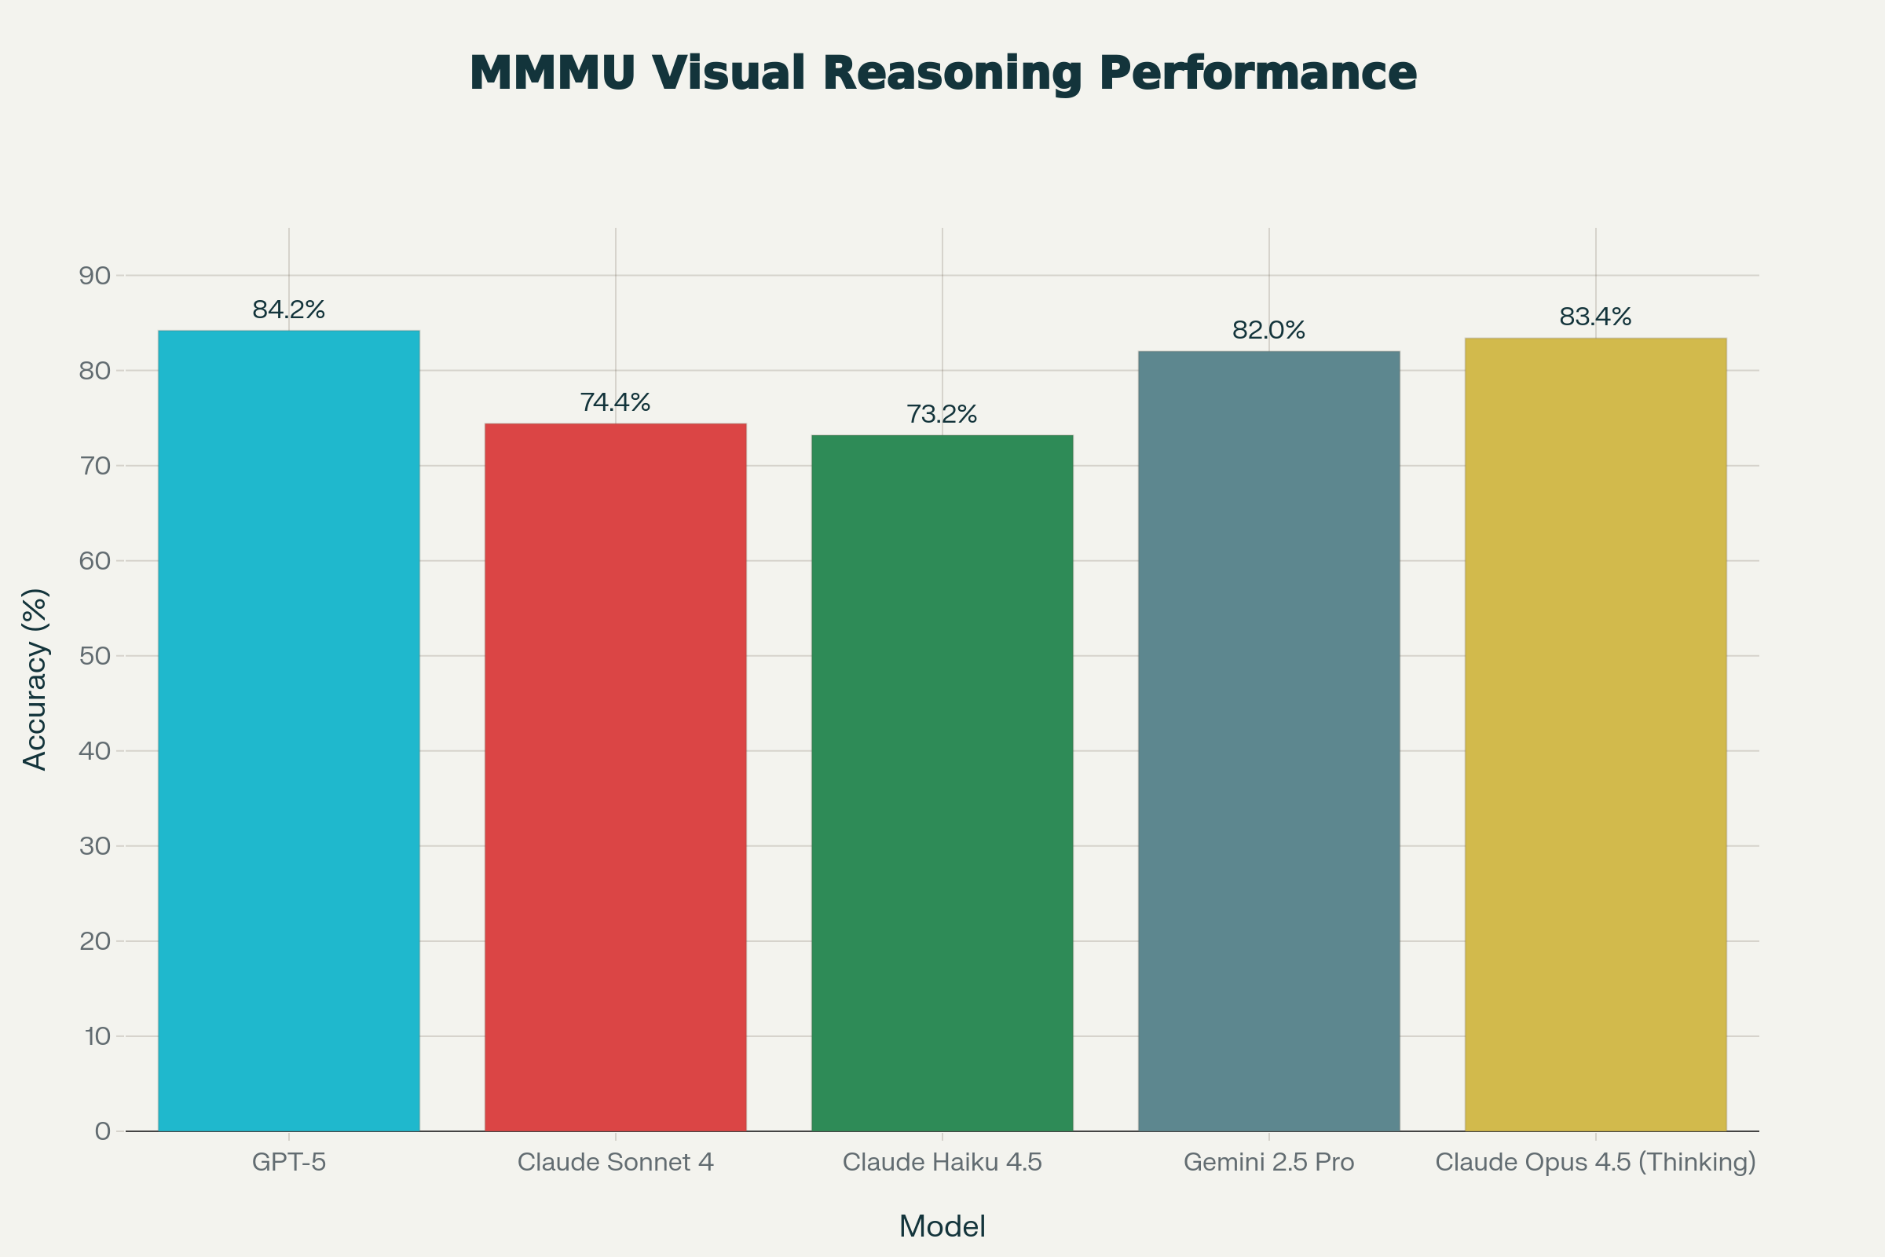
Comparative performance metrics for multimodal LLMs: visual reasoning accuracy on MMMU benchmark and first token latency for image processing tasks
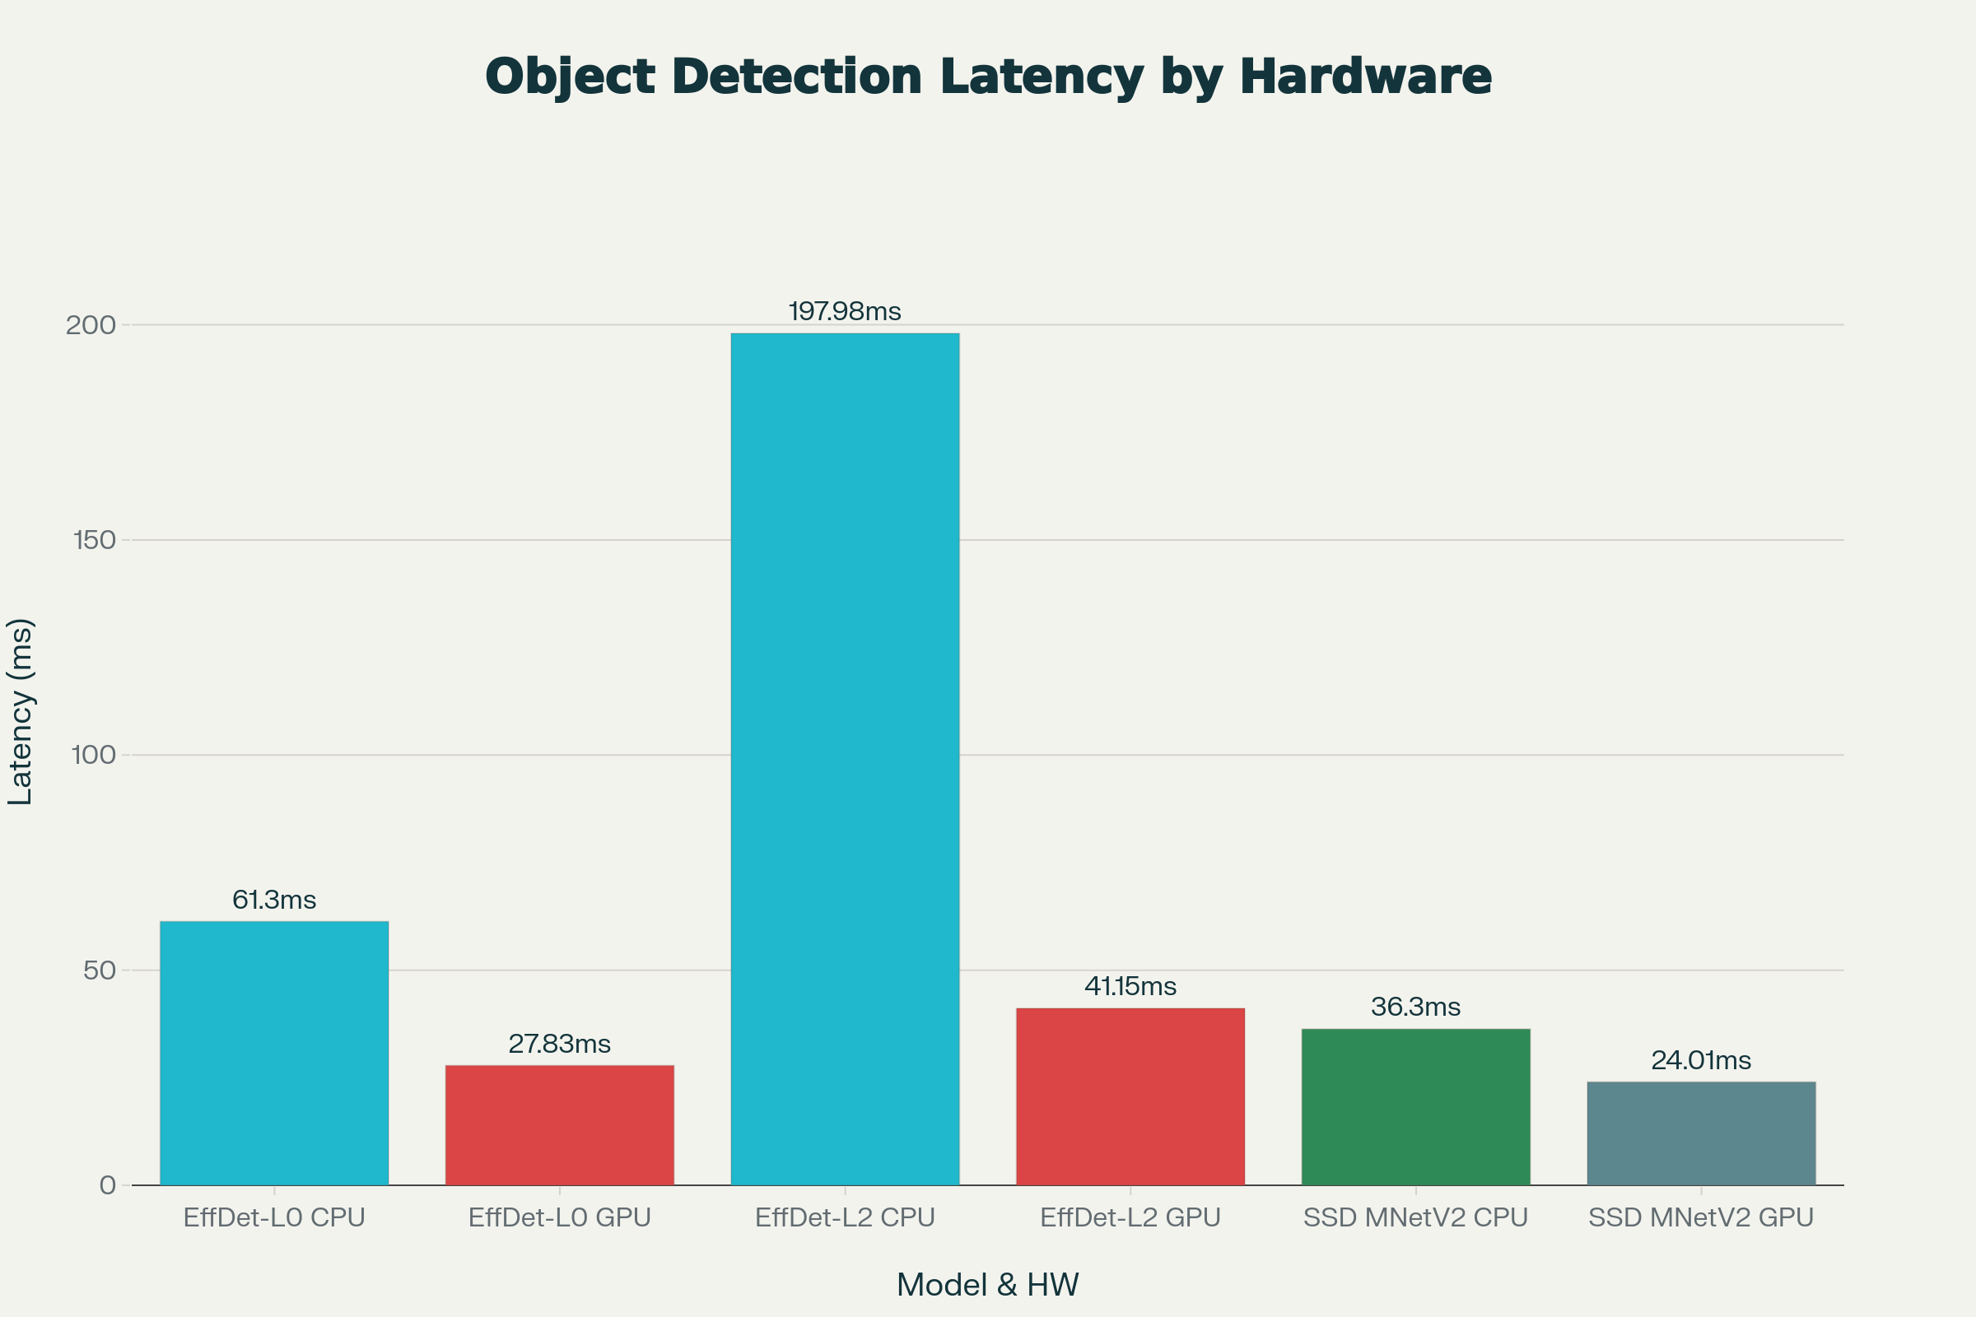
Medical image analysis accuracy and object detection latency benchmarks across different models and hardware configurations

Industry Benchmarks for GenAI Image Recognition
1. Visual Reasoning Across Leading Models (MMMU Benchmark)
The industry has converged on the MMMU benchmark as a standard for evaluating multimodal understanding. Leading results include:
Model | Accuracy | Key Strengths
GPT-5 | 84.2% | State-of-the-art visual reasoning
Claude Opus 4.5 (Thinking) | 83.4% | Reasoning-enhanced accuracy
Gemini 2.5 Pro | 82.0% | Balanced performance
Claude Sonnet 4 | 74.4% | Solid mid-tier performance
Claude Haiku 4.5 | 73.2% | Efficient compact model

GPT-4V and other models achieve only 56% accuracy on the original MMMU benchmark, indicating significant performance improvements in 2025 models. However, the benchmark reveals a critical insight: for specialized image types (geometric shapes, music sheets, chemical structures), even state-of-the-art models achieve near-random accuracy, indicating that visual understanding remains challenging at the frontier.^{[4]}
2. Medical Image Analysis Benchmarks
A comprehensive study comparing ChatGPT-4o, Gemini 2.5 Pro, and Claude 4 Opus on brain MRI image analysis demonstrates significant performance variance:^{[9]}
Task | ChatGPT-4o | Gemini 2.5 Pro | Claude 4 Opus
MRI Sequence Classification | 97.69% | 93.08% | 73.08%
Imaging Plane Detection | 100% | 100% | 99.23%
Contrast-Enhancement Detection | 98.46% | 98.46% | 95.38%

ChatGPT-4o and Gemini 2.5 Pro both demonstrated significantly higher accuracy on medical imaging tasks compared to Claude 4 Opus, with the gap particularly pronounced in MRI sequence classification where ChatGPT-4o outperformed Claude by 24.61 percentage points. This suggests that frontier models maintain advantages in specialized visual understanding domains.^{[9]}
3. Object Detection and Real-Time Inference Latency
Industry-standard object detection benchmarks show significant latency variation based on hardware acceleration:^{[10]}
EfficientDet-Lite0 (Recommended for balanced latency-accuracy tradeoff):
- CPU Latency: 61.30ms
- GPU Latency: 27.83ms
SSD MobileNetV2 (Lightweight option):
- CPU Latency: 36.30ms
- GPU Latency: 24.01ms
EfficientDet-Lite2 (Higher accuracy):
- CPU Latency: 197.98ms
- GPU Latency: 41.15ms
GPU acceleration delivers 2-8x latency reductions compared to CPU-based inference, with smaller models achieving near real-time processing (24-28ms) suitable for production edge deployments.^{[10]}

First Token Latency (TTFT) Benchmark Comparison
A critical metric for user experience in image recognition applications is time to first token, which includes request queuing, prompt processing (prefill), and network latency:^{[11]}
Model | TTFT | Use Case Suitability
GPT-4o | 0.32s | Real-time chat, instant feedback
Gemini 2.5 Flash | 0.40s | Fast multimodal processing
Claude Sonnet 4.5 | 1.80s | Production applications
Gemini 2.5 Pro | 36.54s | Complex reasoning (longer thinking)

GPT-4o's extremely low TTFT of 0.32 seconds represents nine times faster response than GPT-3.5 and 17 times faster than GPT-4, making it the industry's latency leader for image processing tasks. This dramatic improvement reflects architectural choices optimizing for real-time multimodal interaction.^{[12]}

Image Generation (Text-to-Image) Latency Benchmarks
Text-to-image generation represents a distinct category of GenAI image workload with different latency characteristics. MLCommons' SDXL benchmark establishes industry standards:^{[13]}
Stable Diffusion XL (SDXL):
- 20-30 denoising steps: ~7-10 seconds per 1024×1024 image (depending on hardware)
- 50 denoising steps: ~15-20 seconds per image
- Higher step counts improve quality but increase latency quadratically
Stable Diffusion 1.5 with Quantization:
- FP16 (full precision): 0.708-1.043 seconds per 512×512 image
- INT8 (quantized): 0.629 seconds per 512×512 image
- Quantization provides 30-40% latency improvements with minimal quality loss
Industry data shows GPU acceleration is critical: NVIDIA RTX 4090 achieves 0.629 seconds per image with INT8 quantization, while high-end hardware like RTX 6000 maintains competitive speeds around 1.2-1.5 seconds per 1024×1024 generation.^{[14]}

Latency Optimization Techniques for GenAI Image Processing
1. Model Quantization Impact
Quantization reduces numerical precision (FP32→FP16→INT8→INT4) while maintaining accuracy:^{[15]}
- FP8/INT8 quantization: >99% accuracy recovery with 3-3.5x throughput gains for larger models
- INT4 quantization: ~98% accuracy recovery on larger models (Qwen2-VL-72B, Pixtral-Large)
- Smaller models (Qwen2.5-VL-3B): More modest gains (1.1-1.5x) due to lower memory bandwidth requirements
For production deployments, quantized vision-language models reduce latency while improving request throughput by 2.2-3.2x without requiring changes to application code.^{[15]}
2. Prompt Caching and Preemptive Analysis
Research reveals that preemptive image analysis initiated when images are uploaded (before text input) reduces time to first token by preprocessing image tokenization in parallel. AWS Bedrock's prompt caching feature can reduce TTFT by an additional 80-90% for repeated requests, making cached multimodal queries near-instantaneous.^{[16][17]}
3. Vision Encoder Architecture Choices
Apple's FastVLM research demonstrates that hybrid vision encoders (FastViT-based) provide superior accuracy-latency tradeoffs compared to pure transformer-based approaches:^{[18]}
- FastVLM (FastViT-HD): 3x faster than ViT-based models for identical accuracy
- EfficientViT: 20x faster than ViT-L/14 with only 8x smaller size
- Vision encoder latency dominates at high resolutions (1024×1024+)

Strategic Context: Claude Haiku 4.5 Positioning
Claude Haiku 4.5 represents a deliberate optimization of the frontier-capabilities-per-latency tradeoff. At $1/$5 per million tokens (input/output pricing), it costs one-third of Claude Sonnet 4 while operating 4-5 times faster than Claude Sonnet 4.5. For image recognition applications where users can tolerate 1-2 second response times, Haiku 4.5's 73.2% MMMU accuracy delivers compelling economics compared to larger models.^{[19][20][6][21]}
The model excels in multi-agent scenarios where parallel inference matters more than individual request speed. Running 10 Haiku agents in parallel costs $50 per million tokens (vs. $150+ for Sonnet agents) and completes in 20 seconds total, compared to 100+ seconds with older approaches. For specialized medical imaging or domain-specific visual understanding where accuracy is paramount, larger models like GPT-4o or Gemini 2.5 Pro justify their latency overhead through superior accuracy (97-98% medical imaging classification vs. ~73%).^{[20][9]}

Key Takeaways for Production Deployment
- For real-time applications (sub-500ms response requirement): GPT-4o, Gemini 2.5 Flash, or optimized open-source models (Qwen2.5-VL-7B) are necessary despite higher costs.
- For cost-sensitive image understanding: Claude Haiku 4.5 delivers 73.2% accuracy on complex visual reasoning at exceptional cost efficiency.
- For medical/specialized domains: GPT-4o (97.69% medical accuracy) justifies 1-3 second latency through superior domain performance.
- For image generation: Quantized Stable Diffusion models achieve 0.6-1 second per-image latency with competitive quality.
- For throughput-focused deployments: Quantization (INT8) and distributed inference provide 3-5x latency improvements without model changes.
⁂

- https://www.datacamp.com/blog/anthropic-claude-haiku-4-5
- https://www.datacamp.com/es/blog/anthropic-claude-haiku-4-5
- https://binaryverseai.com/claude-haiku-4-5-review-pricing-usage-benchmarks/
- https://mmmu-benchmark.github.io
- https://www.vals.ai/benchmarks/mmmu
- https://www.anthropic.com/news/claude-haiku-4-5
- https://www.youtube.com/watch?v=aA9KP7QIQvM
- https://www.rdworldonline.com/claude-sonnet-4-5-pushes-coding-sota-but-its-physics-intuition-still-lags/
- https://pmc.ncbi.nlm.nih.gov/articles/PMC12345967/
- https://ai.google.dev/edge/mediapipe/solutions/vision/object_detector
- https://www.emergentmind.com/topics/time-to-first-token-ttft
- https://www.datacamp.com/blog/what-is-gpt-4o
- https://mlcommons.org/2024/08/sdxl-mlperf-text-to-image-generation-benchmark/
- https://www.storagereview.com/procyon-ai-text-and-image-generation-benchmark
- https://developers.redhat.com/articles/2025/04/01/enable-faster-vision-language-models-quantization
- https://www.tdcommons.org/cgi/viewcontent.cgi?article=8578&context=dpubs_series
- https://www.linkedin.com/posts/hrushig_ai-amazonbedrock-claude-activity-7355847599242833923-hH8G
- https://machinelearning.apple.com/research/fast-vision-language-models
- https://blog.promptlayer.com/claude-haiku-4-5-initial-reactions/
- https://www.reddit.com/r/ClaudeCode/comments/1o896ju/claude_haiku_45_hits_733_on_swebench_for_15_per/
- https://www.reddit.com/r/ClaudeAI/comments/1o89nko/claude_haiku_45_hits_733_on_swebench_for_15_per/
- https://zencoder.ai/blog/claude-haiku-4-5
- https://www.infoq.com/news/2025/11/claude-haiku-4-5-release/
- https://www.qodo.ai/blog/thinking-vs-thinking-benchmarking-claude-haiku-4-5-and-sonnet-4-5-on-400-real-prs/
- https://www.anthropic.com/claude/haiku
- https://www.vellum.ai/blog/gpt-4o-mini-v-s-claude-3-haiku-v-s-gpt-3-5-turbo-a-comparison
- https://milvus.io/ai-quick-reference/what-are-the-latency-benchmarks-for-leading-ai-databases
- https://www.hixx.ai/blog/awesome-ai-tools/claude-haiku-45-features
- https://developer.nvidia.com/blog/measuring-generative-ai-model-performance-using-nvidia-genai-perf-and-an-openai-compatible-api/
- https://www.deeplearning.ai/the-batch/claudes-haiku-boasts-top-performance-fast/
- https://fal.ai/learn/devs/gen-ai-performance-optimization
- https://github.com/MMMU-Benchmark/MMMU/blob/main/README.md
- https://research.aimultiple.com/llm-latency-benchmark/
- https://www.databricks.com/blog/llm-inference-performance-engineering-best-practices
- https://labelyourdata.com/articles/data-annotation/gpt4-vision
- https://skywork.ai/blog/claude-4-5-vs-3-5-3-7-speed-vs-accuracy-comparison-2025/
- https://developers.redhat.com/articles/2025/02/27/vllm-v1-accelerating-multimodal-inference-large-language-models
- https://www.vellum.ai/blog/llama-3-70b-vs-gpt-4-comparison-analysis
- https://www.anthropic.com/claude/sonnet
- https://arxiv.org/html/2506.06579v1
- https://qed.usc.edu/paolieri/papers/2025_valuetools_transformers_inference_latency.pdf
- https://teamai.com/blog/large-language-models-llms/understanding-the-different-gemini-models/
- https://arxiv.org/html/2503.02891v3
- https://www.reddit.com/r/googlecloud/comments/1kfozrn/gemini_25_pro_extremely_high_latency_on_large/
- https://ieeexplore.ieee.org/iel8/7755/11154819/10971255.pdf
- https://discuss.ai.google.dev/t/facing-high-latency-issue-over-gemini-1-5-pro-during-image-analysis/52460
- https://www.siliconflow.com/articles/en/best-llms-optimized-for-inference-speed
- https://aws.amazon.com/about-aws/whats-new/2025/10/claude-4-5-haiku-anthropic-amazon-bedrock/
- https://docs.nvidia.com/nim/benchmarking/llm/latest/metrics.html
- https://aws.amazon.com/bedrock/anthropic/
- https://creatoreconomy.so/p/chatgpt-vs-claude-vs-gemini-the-best-ai-model-for-each-use-case-2025
- https://www.baseten.co/blog/how-to-benchmark-image-generation-models-like-stable-diffusion-xl/
- https://www.digitalocean.com/solutions/low-latency-inference
- https://www.searchenginejournal.com/chatgpt-vs-gemini-vs-claude/483690/
- https://developer.nvidia.com/blog/deploying-a-scalable-object-detection-inference-pipeline/
- https://www.shadow.do/blog/best-ai-model-in-2025-claude-3-7-vs-gemini-2-5-vs-gpt-4o

